   Atlas Missile Silo   

## Atlas F Documents

This page is where documents pertaining to the Atlas F missile system are located.  It is possible that some items may be listed in more than one location because the item covers more than one missile type.  Click on a thumbnail or PDF link below to view that item.  The PDF  files can be viewed using Adobe Acrobat Reader and you can download your free copy of Acrobat Reader [here](http://www.adobe.com/products/acrobat/readstep2.html).

Many of the items on these pages are available for download to your system.  To save a file to your local computer, right click the PDF file name and choose the "Save Target As" option.

[](http://www.atlasmissilesilo.com/documents_atlas_f_550thSMS.htm)          [](http://www.atlasmissilesilo.com/documents_atlas_f_551stSMS.htm)         [](http://www.atlasmissilesilo.com/documents_atlas_f_556thSMS.htm)  
 [550th SMS](http://www.atlasmissilesilo.com/documents_atlas_f_550thSMS.htm)           [551st SMS](http://www.atlasmissilesilo.com/documents_atlas_f_551stSMS.htm)          [556th SMS](http://www.atlasmissilesilo.com/documents_atlas_f_556thSMS.htm)  
 [Documents](http://www.atlasmissilesilo.com/documents_atlas_f_550thSMS.htm)          [Documents](http://www.atlasmissilesilo.com/documents_atlas_f_551stSMS.htm)        [Documents](http://www.atlasmissilesilo.com/documents_atlas_f_556thSMS.htm)

[](http://www.atlasmissilesilo.com/documents_atlas_f_577thSMS.htm)         [](http://www.atlasmissilesilo.com/documents_atlas_f_578thSMS.htm)         [](http://www.atlasmissilesilo.com/documents_atlas_f_579thSMS.htm)  
  [577th SMS](http://www.atlasmissilesilo.com/documents_atlas_f_577thSMS.htm)          [578th SMS](http://www.atlasmissilesilo.com/documents_atlas_f_578thSMS.htm)         [579th SMS](http://www.atlasmissilesilo.com/documents_atlas_f_579thSMS.htm)  
  [Documents](http://www.atlasmissilesilo.com/documents_atlas_f_577thSMS.htm)         [Documents](http://www.atlasmissilesilo.com/documents_atlas_f_578thSMS.htm)        [Documents](http://www.atlasmissilesilo.com/documents_atlas_f_579thSMS.htm)

The documents in the section below contain general information about the Atlas F silo type missile system.  For documents concerning specific Atlas F squadrons, please visit one of the links above.

***Construction***

[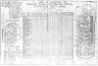](http://www.atlasmissilesilo.com/Documents/Construction/AtlasF/AF-D-C-999-99-ZZ-00001_CEBMCO_AtlasF_ConstructionStatusReport.jpg)

***Diagrams***

[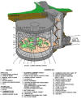](http://www.atlasmissilesilo.com/Documents/Diagrams/AtlasF/AF-G-O-999-99-ZZ-00006_AtlasF_Color_LCCLayout.jpg)    [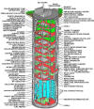](http://www.atlasmissilesilo.com/Documents/Diagrams/AtlasF/AF-G-O-999-99-ZZ-00002_AtlasF_Color_SiloLayout.jpg)    [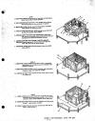](http://www.atlasmissilesilo.com/Documents/Diagrams/AtlasF/AF-G-O-999-99-ZZ-00003_AccessAndWalkways_G-2.jpg)    [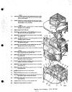](http://www.atlasmissilesilo.com/Documents/Diagrams/AtlasF/AF-G-O-999-99-ZZ-00004_AccessAndWalkways_G-4.jpg)    [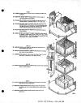](http://www.atlasmissilesilo.com/Documents/Diagrams/AtlasF/AF-G-O-999-99-ZZ-00005_AccessAndWalkways_G-6.jpg)

[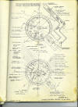](http://www.atlasmissilesilo.com/Blueprints/AtlasF/AF-D-B-999-99-ZZ-00001_LaunchControlCenter.jpg)    [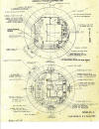](http://www.atlasmissilesilo.com/Blueprints/AtlasF/AF-D-B-999-99-ZZ-00002_SiloLevel_1_2.jpg)    [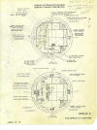](http://www.atlasmissilesilo.com/Blueprints/AtlasF/AF-D-B-999-99-ZZ-00003_SiloLevel_3_4.jpg)    [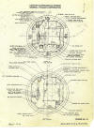](http://www.atlasmissilesilo.com/Blueprints/AtlasF/AF-D-B-999-99-ZZ-00004_SiloLevel_5_6.jpg)    [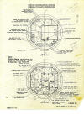](http://www.atlasmissilesilo.com/Blueprints/AtlasF/AF-D-B-999-99-ZZ-00005_SiloLevel_7_8.jpg)

[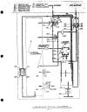](http://www.atlasmissilesilo.com/Documents/Diagrams/AtlasF/AF-G-O-999-99-ZZ-00007_E-01_SiloAirFlowDiagram.jpg)    [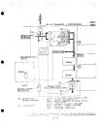](http://www.atlasmissilesilo.com/Documents/Diagrams/AtlasF/AF-G-O-999-99-ZZ-00008_E-02_SiloAirSupplyFans.jpg)    [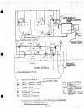](http://www.atlasmissilesilo.com/Documents/Diagrams/AtlasF/AF-G-O-999-99-ZZ-00009_E-03_AirWasherDustCollectorFlowDrawings.jpg)    [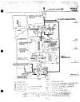](http://www.atlasmissilesilo.com/Documents/Diagrams/AtlasF/AF-G-O-999-99-ZZ-00010_E-04_MainExhaustAirSystemAndMissileEncolsureAreaPurgeSystem.jpg)    [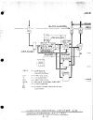](http://www.atlasmissilesilo.com/Documents/Diagrams/AtlasF/AF-G-O-999-99-ZZ-00011_E-05_LCCAirConditioningSystem.jpg)

[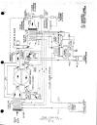](http://www.atlasmissilesilo.com/Documents/Diagrams/AtlasF/AF-G-O-999-99-ZZ-00012_E-06_PodCooler.jpg)    [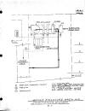](http://www.atlasmissilesilo.com/Documents/Diagrams/AtlasF/AF-G-O-999-99-ZZ-00013_E-07_MissileEnclosureAreaAirConditioningSystemi.jpg)    [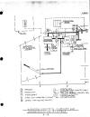](http://www.atlasmissilesilo.com/Documents/Diagrams/AtlasF/AF-G-O-999-99-ZZ-00014_E-08_LCCCabinetAirConditioningSystem.jpg)    [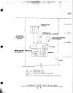](http://www.atlasmissilesilo.com/Documents/Diagrams/AtlasF/AF-G-O-999-99-ZZ-00015_E-09_ThrustHeatingSystem.jpg)    [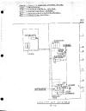](http://www.atlasmissilesilo.com/Documents/Diagrams/AtlasF/AF-G-O-999-99-ZZ-00016_E-10_UtilityAirSystem.jpg)

[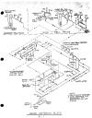](http://www.atlasmissilesilo.com/Documents/Diagrams/AtlasF/AF-G-O-999-99-ZZ-00017_E-11_WaterSofteningBuilding.jpg)    [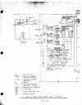](http://www.atlasmissilesilo.com/Documents/Diagrams/AtlasF/AF-G-O-999-99-ZZ-00018_E-12_ChilledWaterSystem.jpg)    [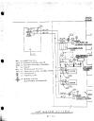](http://www.atlasmissilesilo.com/Documents/Diagrams/AtlasF/AF-G-O-999-99-ZZ-00019_E-13_HotWaterSystem.jpg)    [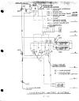](http://www.atlasmissilesilo.com/Documents/Diagrams/AtlasF/AF-G-O-999-99-ZZ-00020_E-14_CondenserWaterSystem.jpg)    [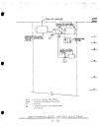](http://www.atlasmissilesilo.com/Documents/Diagrams/AtlasF/AF-G-O-999-99-ZZ-00021_E-15_DemineralizedWaterSystem.jpg)

[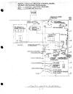](http://www.atlasmissilesilo.com/Documents/Diagrams/AtlasF/AF-G-O-999-99-ZZ-00022_E-16_UtilityWaterSystem.jpg)    [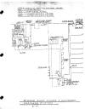](http://www.atlasmissilesilo.com/Documents/Diagrams/AtlasF/AF-G-O-999-99-ZZ-00023_E-17_SewageSumpPumpsAndSanitaryDrainageSystem.jpg)    [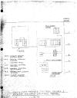](http://www.atlasmissilesilo.com/Documents/Diagrams/AtlasF/AF-G-O-999-99-ZZ-00024_E-18_FacilitiesRemoteControlPanelAndPowerRemoteControlPanel.jpg)    [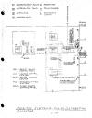](http://www.atlasmissilesilo.com/Documents/Diagrams/AtlasF/AF-G-O-999-99-ZZ-00025_E-19_FacilitiesElectricalPowerDistributionAndLighting.jpg)    [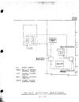](http://www.atlasmissilesilo.com/Documents/Diagrams/AtlasF/AF-G-O-999-99-ZZ-00026_E-20_48VoltStationBattery.jpg)

[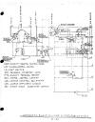](http://www.atlasmissilesilo.com/Documents/Diagrams/AtlasF/AF-G-O-999-99-ZZ-00027_E-21_AutomaticBlastClosureAndDetectorSystem.jpg)    [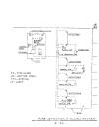](http://www.atlasmissilesilo.com/Documents/Diagrams/AtlasF/AF-G-O-999-99-ZZ-00028_E-22_FireDetectionAndAlarmSystem.jpg)    [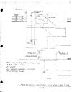](http://www.atlasmissilesilo.com/Documents/Diagrams/AtlasF/AF-G-O-999-99-ZZ-00029_E-23_PersonnelWarningAndAlarmLighting.jpg)    [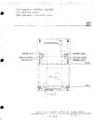](http://www.atlasmissilesilo.com/Documents/Diagrams/AtlasF/AF-G-O-999-99-ZZ-00030_E-24_AirCylinderSpringSupport.jpg)    [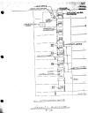](http://www.atlasmissilesilo.com/Documents/Diagrams/AtlasF/AF-G-O-999-99-ZZ-00031_E-25_FacilityElevator.jpg)

[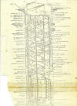](http://www.atlasmissilesilo.com/Documents/Diagrams/AtlasF/AF-G-O-999-99-ZZ-00001_SiloDiagram.jpg)    [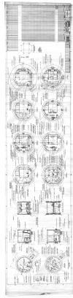](http://www.atlasmissilesilo.com/Blueprints/AtlasF/AF-D-B-999-99-ZZ-00006_AtlasF_GeneralArrangementSilo_Sheet1.jpg)    [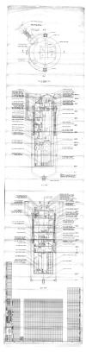](http://www.atlasmissilesilo.com/Blueprints/AtlasF/AF-D-B-999-99-ZZ-00007_AtlasF_GeneralArrangementSilo_Sheet2.jpg)    [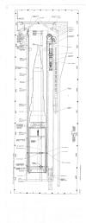](http://www.atlasmissilesilo.com/Blueprints/AtlasF/AF-D-B-999-99-ZZ-00008_Silo_SideView.jpg)

***Development***

(12.5 Mb)     [Integrating Contractors Base Activation Project Manual](http://www.atlasmissilesilo.com/Documents/Operational/AtlasF/AF-D-O-999-99-ZZ-00002_IntegratingContractorsBaseActivationProjectManual.pdf)  
(19 Mb)     [**WS107A-1 Weapon System - Silo Full Scale Mockup Photograph Record**](http://www.atlasmissilesilo.com/Documents/Development/AtlasF/AF-D-T-999-99-ZZ-00001_WS107A-1WeaponSystem_SiloFullScaleMockupPhotographRecord_1961_05_15_Volume1.pdf)

***Deactivation***

(31.3 Mb)     [AFLC Phaseout Atlas E F Titan1](http://www.atlasmissilesilo.com/Documents/Deactivation/AZ-D-D-999-99-ZZ-00001_AFLCPhaseout_AtlasEFTitan1.pdf)  
(8.8 Mb)     [Atlas F Deactivation Procedure A109](http://www.atlasmissilesilo.com/Documents/Deactivation/AtlasF/AF-D-D-999-99-ZZ-00001_AtlasFDeactivationProcedureA109.pdf)  
(3.5 Mb)     [History Of Atlas Phaseout](http://www.atlasmissilesilo.com/Documents/Deactivation/AZ-D-D-999-99-ZZ-00002_HistoryOfAtlasPhaseout.pdf)  
(34.9 Mb)     [SBAMA Equipment Removal Plan - Atlas F](http://www.atlasmissilesilo.com/Documents/Deactivation/AtlasF/AF-D-D-999-99-ZZ-00002_SBAMAEquipmentRemovalPlan_AtlasF.pdf)  
(22.8 Mb)     [SBAMA Phaseout Atlas E F Titan1](http://www.atlasmissilesilo.com/Documents/Deactivation/AZ-D-D-999-99-ZZ-00003_SBAMAPhaseout_AtlasEFTitan1.pdf)  
(2.8 Mb)     [USAF Plan For Atlas Titan Phaseout](http://www.atlasmissilesilo.com/Documents/Deactivation/AZ-D-D-999-99-ZZ-00004_USAFPlanForAtlasTitanPhaseout.pdf)

***General Dynamics***

(17.8 Mb)     [Atlas E/F - Ground Operational Equipment List](http://www.atlasmissilesilo.com/Documents/Operational/AZ-D-O-999-99-ZZ-00002_GroundOperationalEquipmentList_AtlasEandF.pdf)  
(53.1 Mb)     [Atlas E/F - Ground Support Equipment List](http://www.atlasmissilesilo.com/Documents/Operational/AZ-D-O-999-99-ZZ-00003_GroundSupportEquipmentList_AtlasEandF.pdf)

***Miscellaneous***

(2.3 Mb)     [Atlas E-F Launch Vehicle - Unsung Workhorse](http://www.atlasmissilesilo.com/Documents/Operational/AZ-D-O-999-99-ZZ-00005_Atlas_E_F_LaunchVehicle_UnsungWorkhorse.pdf)

***Operational***

(2.6 Mb)     [Abbreviated Check List - DMCCC](http://www.atlasmissilesilo.com/Documents/Operational/AtlasF/AF-D-O-999-99-ZZ-00003_AbbreviatedChecklist_DMCCC.pdf)  
(14.5 Mb)     [Abbreviated Check List - Emergency Procedures](http://www.atlasmissilesilo.com/Documents/Operational/AtlasF/AF-D-O-999-99-ZZ-00004_AbbreviatedChecklist_EmergencyProcedures_MissileCombatCrew.pdf)

***Technical Orders  (T.O. Library)***

(95.4 Mb)     [21M-HGM16F-1   "DASH ONE"](http://www.atlasmissilesilo.com/Documents/Operational/AtlasF/AF-D-O-999-99-ZZ-00001_AtlasF_DashOne.pdf)

[](http://www.adobe.com/products/acrobat/readstep2.html)

